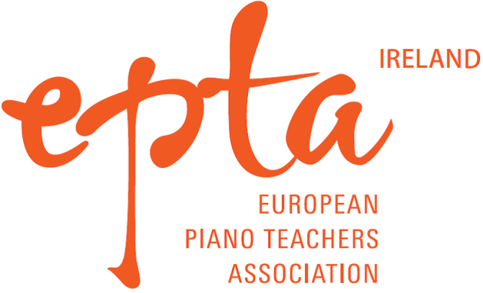

CHRISTMAS CONCERT

Concert: Sunday 28th November 2021

APPLICATION FORM:
Closing date for applications: Mondy 22nd November

Name of student/s: ___________________________ Age:__________
__________________________________________ Age:__________
Teacher: __________________________ Contact No:_____________

One or Two Pieces (piano solo/duets) to be performed,

max duration 8 mins:

1 Composer:____________ Title:_____________________________ Duration: ________

2 Composer:____________ Title:_____________________________ Duration: ________

Completed application forms to be sent to:
EPTA Ireland, 16 Rowanbyrn, Blackrock, Co Dublin
Or email to info@epta.ie

